# Font Evaluation

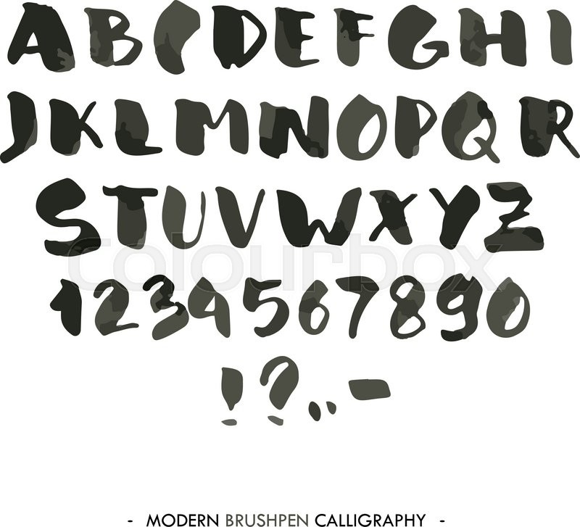

Strengths:

* The font is clear to read despite the unique look meaning a viewer would be able to read what it says, which is critical because if the viewer doesn’t know what its saying then they won’t know what the logo is for.
* The font is very visually appealing but also has a unique and almost random look to it which could be related to the event which is unique in itself but also somewhat random as the activities within the event are quite random.
* The font suits the target audience because its quite random and messy which could be linked to the type of music played at the event, metal and rock, which sounds quite messy and random at the start, and to an extent the music is random because some parts of songs are made up on the spot which differs the live performance from the studio recording.
* The font would stand out due to how different it is to other fonts, which means it would draw attention to itself.

Weaknesses:

* Would be quite hard to use alongside another element of a logo as it wouldn’t match with anything which would make it hard to use despite the fact it would work well.

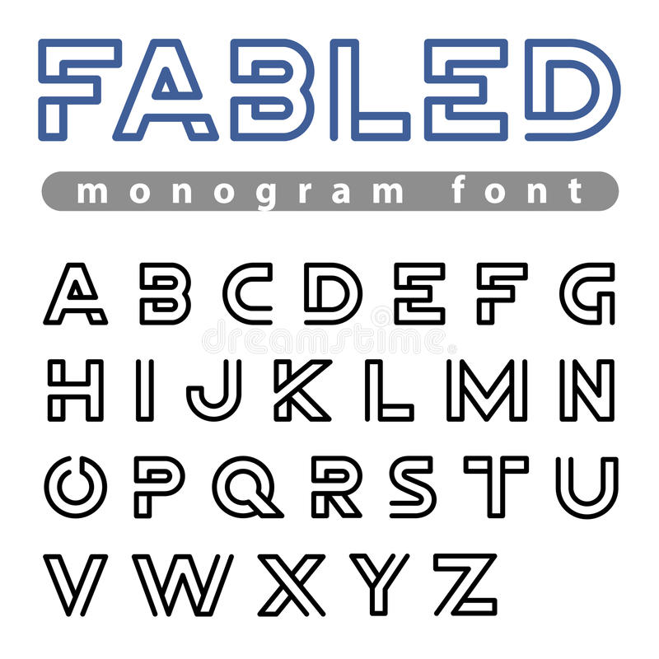

Strengths:

* Clear to read however some letters are quite hard to read, although the letters needed to write out download are not hard to read.
* Stands out from other text and would work well on a logo, as other elements of the logo could be drawn in the same style as the font, for example a guitar could be drawn around the font using lines with gaps in between which would match the font.
* Sans serif font meaning it looks more modern and makes it easier to read.

Weaknesses:

* Doesn’t suit the target audience/music genre of Download meaning it wouldn’t work well on a logo or other elements of the branding as the target audience might not link that the branding is for the rock festival rather than for another festival with the same name.

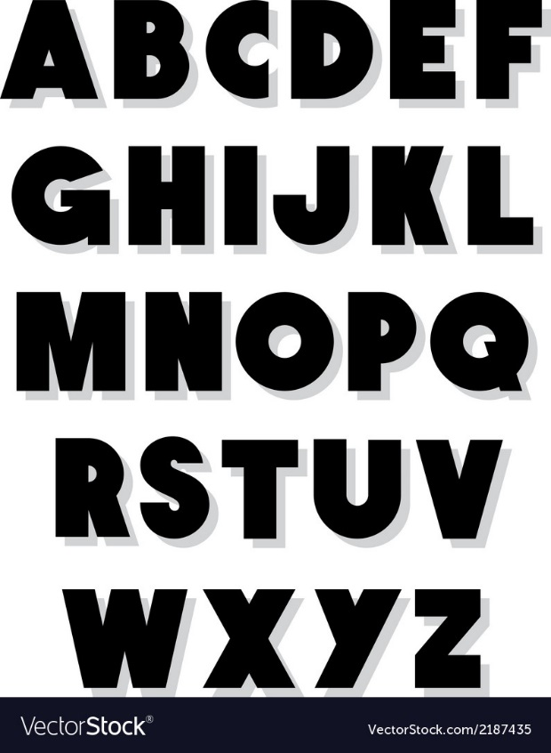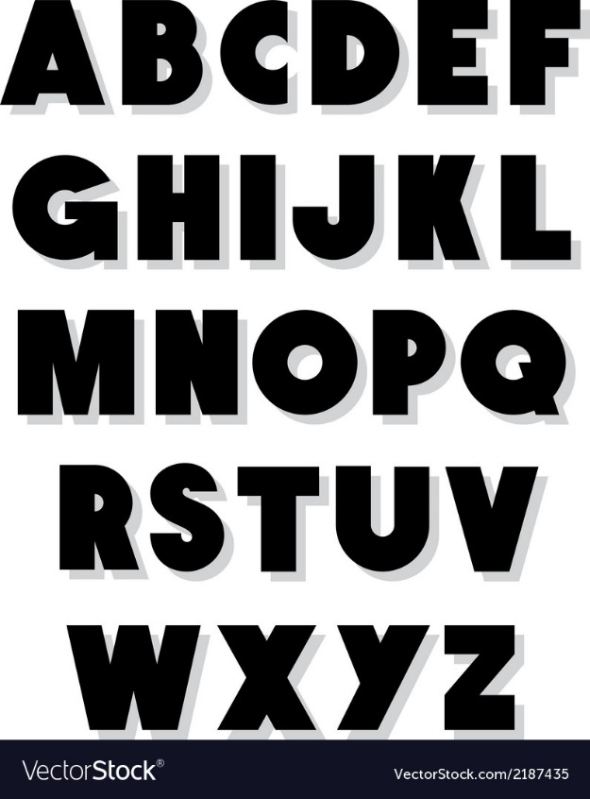

Strengths:

* Clear to read meaning everyone would be able to read it
* Doesn’t necessarily suit the target audience, but its generic enough that it could be used for the logo and it would work well

Weaknesses:

* Quite boring and wouldn’t draw attention to itself and wouldn’t stand out

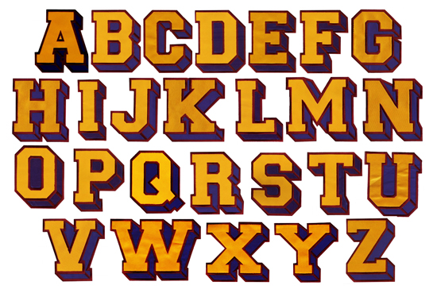

Strengths:

* Would stand out from other fonts meaning more people would see it
* Would draw attention to itself as the font itself is bold and large, but also the bright colours would draw someone’s attention.
* It suits the target audience to an extent but not very well, which means that some people might not realise that the logo is for the rock festival rather than something else with the name download

Weaknesses:

* The font doesn’t suit the target audience well enough for it to draw the right people in

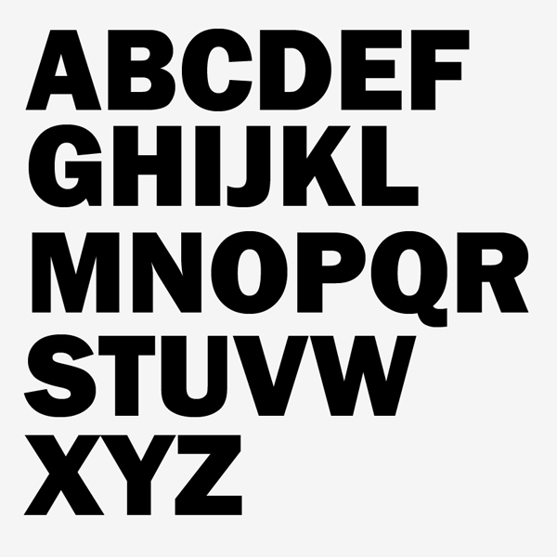

Strengths:

* This font is very easy to read, much like the third font
* It stands out due to the full caps, however most of the fonts chosen also to have this going for them

Weaknesses:

* The issue with this font is that it doesn’t have any special or interesting attributes which means it doesn’t draw the viewers attention and therefore wouldn’t be a good fit as the font of choice, as there are much more interesting fonts which would do a better job.

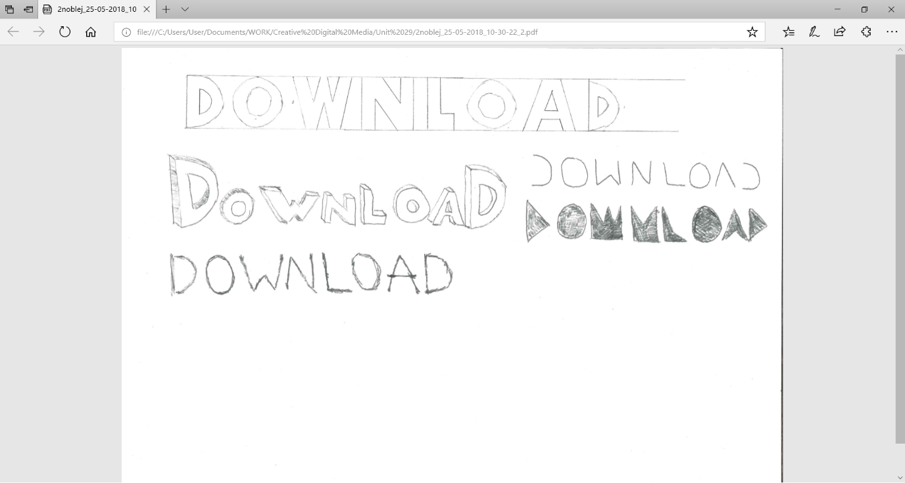

Strengths:

* The change of size of the first and last character give this font some randomness which could be related to the random and crazy event that is download
* The 3D characters provide an interesting unique attribute for the font which could draw a viewer’s attention.

Weaknesses:

* The font is a bit cartoony, which doesn’t really relate to the event and therefore the target audience.

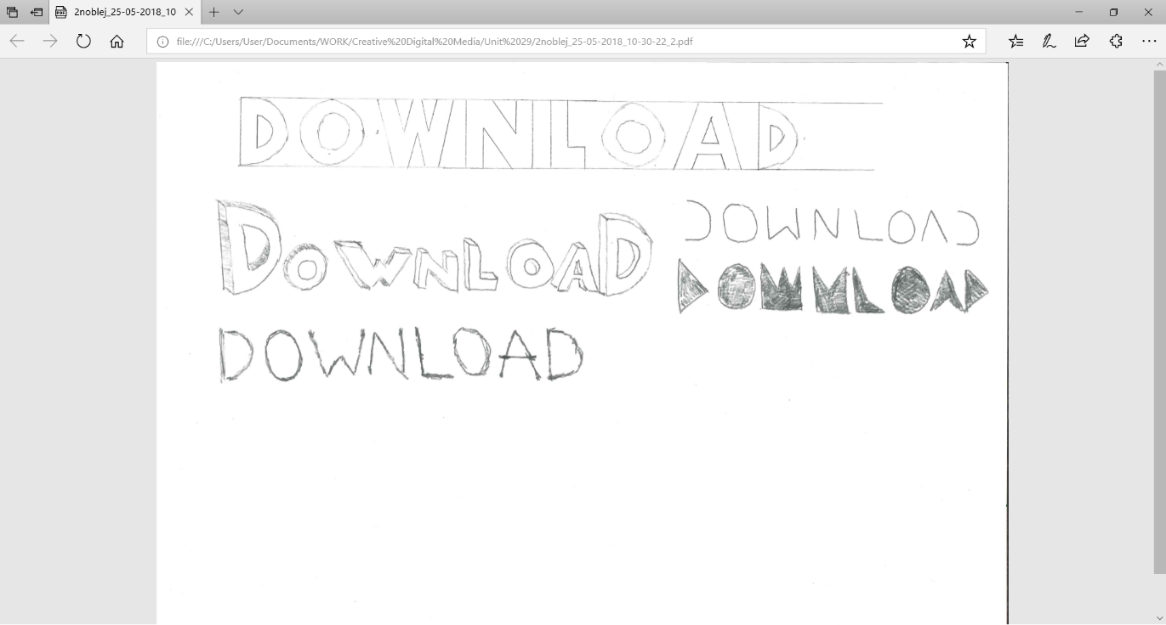

Strengths:

* Clear to read and can therefore be read by anyone, which would include the target audience.
* The messy style of the font suits the event which is quite messy due to the fact its in a field which can but muddy.

Weaknesses:

* Quite thin and therefore might not come out well if it was printed for a billboard or to be put on a poster

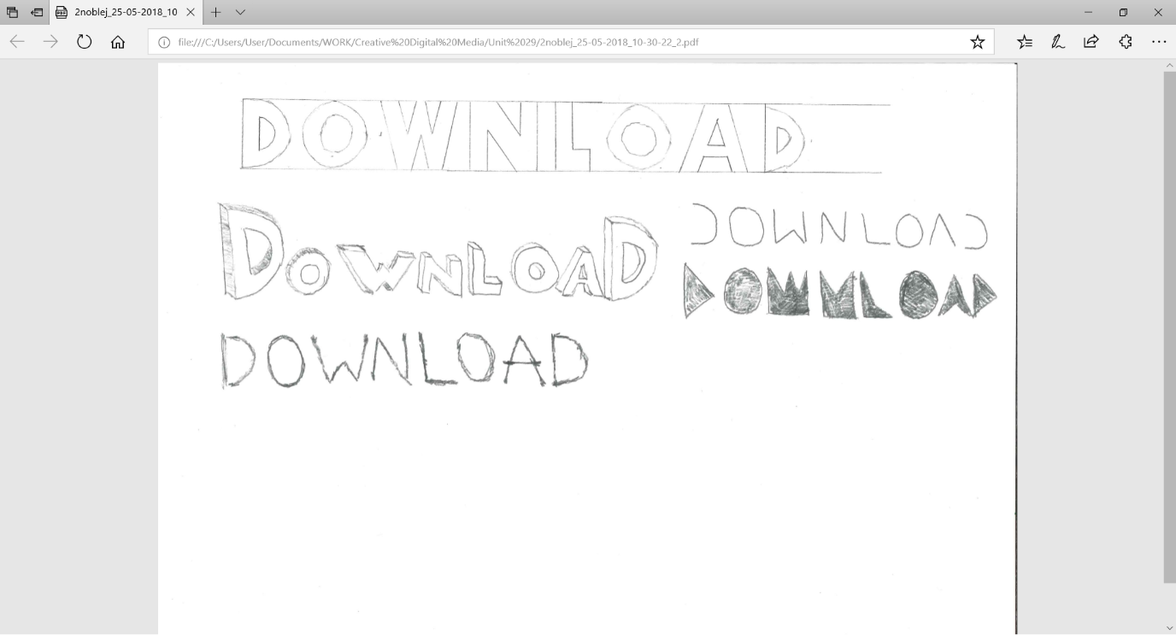

Strengths:

* Looks quite nice and would draw someone’s attention because it’s quite unique

Weaknesses:

* Not very clear to read, due to letters such as “A” and “D” are missing large sections which can make it quite hard to read. This could mean that some people might not be able to read what it says which could result in people not understanding what the event is or what it called.

Strengths:

* The font is unique and would stand out amongst nearly every other font.
* Although the font could be hard to read by some, this would be able to be overcome as the style of the font makes up for the difficulty to read.

Weaknesses:

* As said before, the font is the most difficult out of any of the others to read. this means that potentially, some people might have difficulties reading the font and might not understand what its saying and therefore won’t realise its advertising a festival.

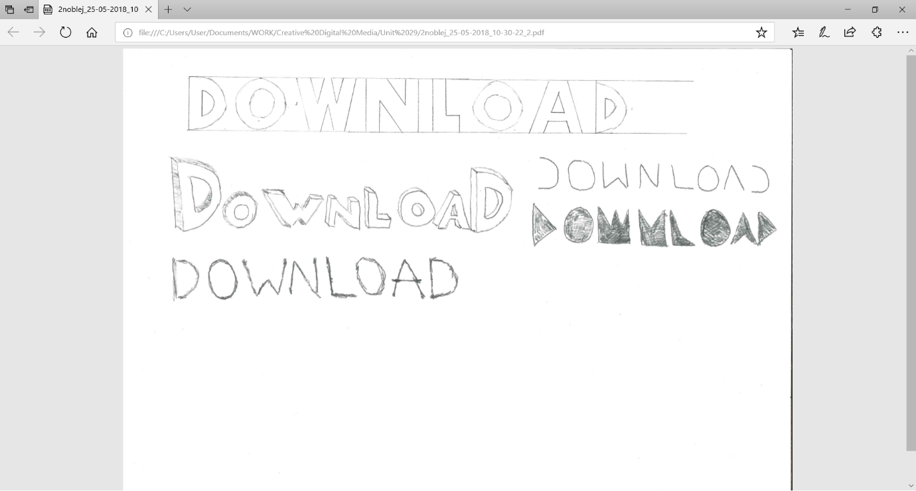

Strengths:

* The font is very similar to some earlier fonts and shares a lot of similarities, such has been easy to read but also bold and would stand out.
* The font has a transparent centre and consists of only the outline of the letters. This means it could be used over the top of an image without covering elements of it. this would make it ideal for use on a poster where images cover every element of the page.

Weaknesses:

* The font has a very limited use case, so although it would work over the top of images it wouldn’t work as well as other fonts in other places, such as on a logo or text on a website.

the target audience would be expecting a font more like the first one or the second to last one, as they quite messy and spontaneous which could represent the music they are going to watch, but also the event itself which is known for being messy and a bit crazy. This makes it the best choice for attracting the target audience. The first font would be quite difficult to implement into a logo design; however, I think the second to last font would work well in logo design. The font consists of a lot of triangles, and I think a logo with a similar ethos could be created and would look visually pleasing and would work well for the target audience.